<https://www.w3schools.com/sql/trysql.asp?filename=trysql_select_all>

<https://www.w3schools.com/sql/default.asp>

**Listar los nombres de las personas que tienen al menos 2 nietos**

| Result: |  |
| --- | --- |
| Number of Records: 4 |  |
| **name** | **grandsons** |
| Rosa | 4 |
| José | 4 |
| María | 2 |
| Carlos | 2 |

CREATE TABLE person (

id int,

name varchar(30),

age int

)

CREATE TABLE parent (

personId int,

parentId int

)

INSERT INTO person (id, name, age) VALUES

(1, "Carlos", 72),

(2, "María", 73),

(3, "José", 68),

(4, "Rosa", 71),

(5, "Juan", 52),

(6, "Marcela", 50),

(7, "Bernardo", 50),

(8, "Camila", 51),

(9, "Sebastián", 53),

(10, "Roberta", 52),

(11, "Camilo", 49),

(12, "Julia", 28),

(13, "Romina", 29),

(14, "Miguel",30),

(15, "Antonia", 27),

(16, "Carla", 7),

(17, "Ricardo", 6),

(18, "Felipe", 5)

INSERT INTO parent (personId, parentId) VALUES

(5, 1),

(5, 2),

(6, 1),

(6, 2),

(7, 1),

(7, 2),

(8, 1),

(8, 2),

(9, 3),

(9, 4),

(10, 3),

(10, 4),

(11, 3),

(11, 4),

(12, 8),

(12, 9),

(13, 5),

(13, 10),

(16, 12),

(16, 14),

(17, 11),

(17, 15),

(18, 11),

(18, 15)

**Respuesta al Query especificado:**

WITH oldestparentgroup as (

Select person.id, parent.parentid, person.name, person.age, parent.personid as sonsid

From person

Left Join parent

On person.id = parent.parentid

Where age >= 65

order by age Desc

)

Select oldestparentgroup.name, count(personid) as grandsons

From oldestparentgroup

Right Join parent

On oldestparentgroup.sonsid = parent.parentid

Where name is not null

Group by name

Order by grandsons Desc

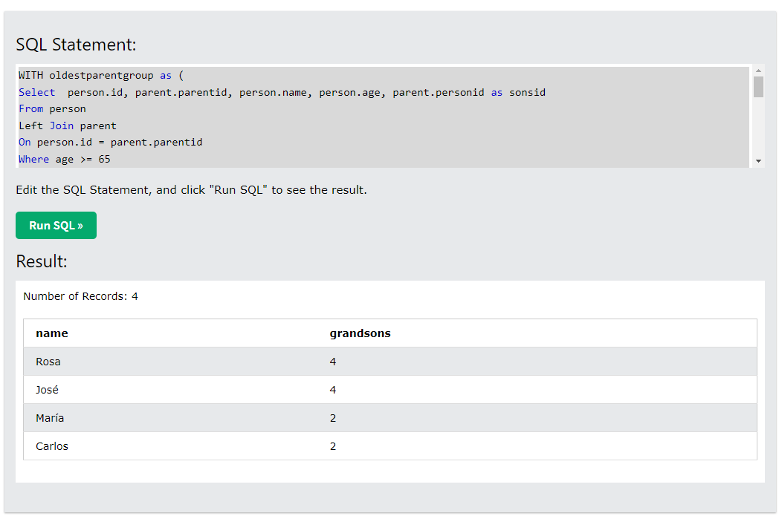

Hola ya quedo listo.